Model Classification

The classification model takes fruit images and categorizes them into six classes. It works by analyzing visual features such as:
- Color – bright for fresh, dark for rotten
- Texture – smooth vs. wrinkled
- Shape – intact vs. deformed
After preprocessing the dataset, the model is trained on labeled examples. It learns patterns in the features and uses this knowledge to classify new images with accuracy

What is Model Classification?
Model classification means the system takes an input image and assigns it to one of the predefined categories such as:
- Fresh apple
- Rotten apple
- Fresh banana
- Rotten banana
- Fresh orange
- Rotten orange
So the model’s job is to look at an image and decide which class it belongs to

Our model classifies images of fruits into categories like fresh apple, rotten apple, fresh banana, etc. The classification happens in two main steps: feature extraction and prediction. First, the model reads each image and analyzes important features such as color (red, yellow, brown), texture (smooth or wrinkled), and shape. These features tell the model whether a fruit looks fresh or spoiled.
After preprocessing and scaling the features, the model is trained on labeled images. During training, it learns patterns—like fresh fruits having brighter colors and smooth textures, while rotten fruits often appear darker or patchy. Finally, when a new image is given, the model compares it with what it learned and predicts the correct class

Step A — Preprocessing
The images are:
- Resized
- Normalized
- Sometimes augmented (rotation, zoom, flip)
These steps help improve accuracy and reduce noise.
Step B — Feature Extraction
You extracted features such as:
✔ Color features
– Fresh fruits usually have bright and uniform colors
– Rotten fruits appear brownish, dark, or discolored
✔ Texture features
– Fresh fruits are smoother
– Rotten fruits show wrinkles, dents, mushy patches
✔ Shape features
– Rotten fruits may lose original shape
You also computed:
- Mean pixel intensity
- Standard deviation
- Individual R, G, B channel visualizations
These features help the model understand patterns in the image.
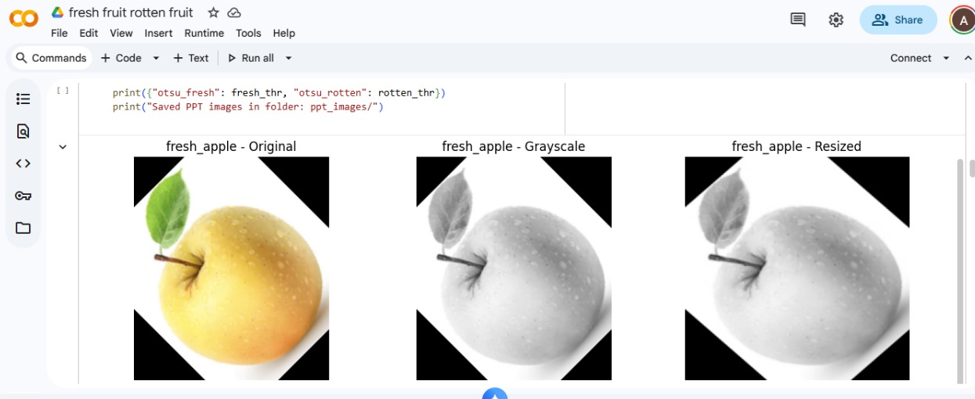
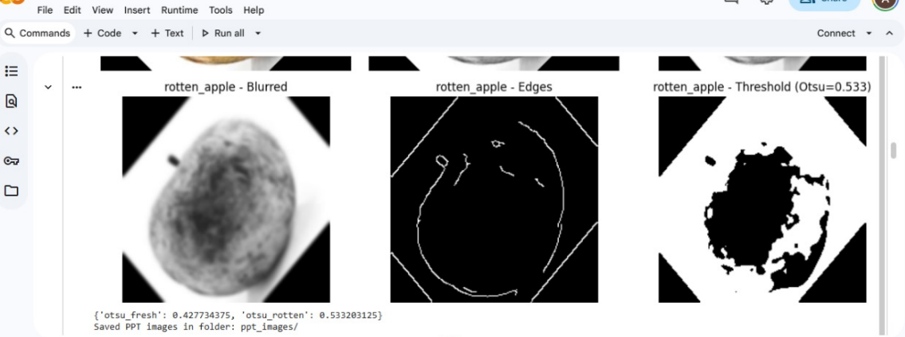
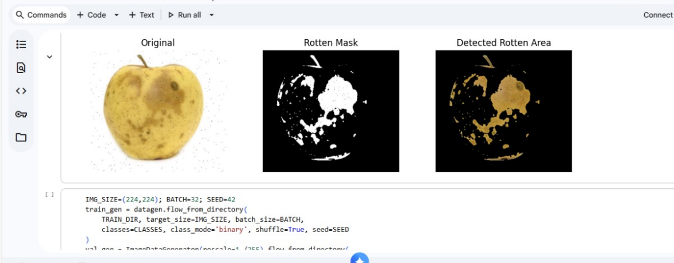

Step B— Classification (Prediction Stage)
When you give a new fruit image, the model:
- Preprocesses the image
- Extracts features
- Compares these features with learned patterns
- Outputs the predicted class (e.g., “rotten banana”)
